

# 

# Product Dissection for Flipkart

## **Company Overview :**

Founders: Sachin Bansal & Binny Bansal

Founded in: October 2007

Headquarters: Bangalore,India

Flipkart was founded in October 2007 in Bangalore by Sachin Bansal and Binny Bansal, alumni of the IIT, Delhi and former Amazon employees.The company was started from a two-bedroom apartment in Koramangala, Bengaluru. The website was kicked off in October 2007 and the company was only limited to selling books at that time.The company initially focused on online book sales with country-wide shipping.

Flipkart expanded their services and product categories, becoming a one-stop shop for consumers by offering everything from electronics and clothing to groceries.

Flipkart acquires multiple businesses to become a one stop shop such as Myntra,mime360.com,Letsbuy and many more.

## **Product Dissection and Real-World Problems Solved by Flipkart:**

Flipkart, being one of India's leading e-commerce platforms, offers a diverse range of products across multiple categories. Here's a dissection of Flipkart's product offerings:

**1. Electronics:**

Flipkart's electronics category includes smartphones, laptops, tablets, cameras, televisions, audio equipment, and other electronic accessories.It offers products from various brands ranging from budget-friendly options to premium ones, catering to a wide range of consumer preferences and budgets.

**2. Fashion:**

The fashion category on Flipkart encompasses clothing, footwear, accessories, and jewelry for men, women, and kids.

It features a mix of Indian and western wear, including ethnic wear, casual wear, formal wear, sportswear, and many more.

Flipkart collaborates with both domestic and international brands, as well as featuring its private labels, offering a diverse range of styles and price points to its customers.

**3. Home Essentials:**

Flipkart offers a comprehensive range of home essentials including furniture, home decor, kitchenware, dining, furnishings, and appliances.

Customers can find products for every room in the house, catering to various tastes, preferences, and budgets.

**4. Groceries:**

In recent years, Flipkart has expanded its offerings to include groceries and daily essentials.

Customers can purchase groceries, fresh produced vegetables and fruits, pantry staples, personal care, and household items from trusted brands.

The platform also offers features like scheduled deliveries, subscription services, and discounts to enhance convenience and affordability for grocery shoppers.

**5. Beauty and Personal Care:**

Flipkart's beauty and personal care category features a wide range of skincare, haircare, makeup, grooming, and wellness products.

It includes products from famous brands as well as emerging ones, catering to diverse skin types, concerns, and preferences.though customers can shop the products according to there skin type.

.

**6. Books, Toys, and Stationery:**

Flipkart offers a wide collection of books, e-books, toys, games, puzzles, stationery, and school supplies.Customers can find bestsellers, educational materials, fiction, non-fiction, children's books, and more, catering to readers of all age groups and genres.

**7. Automotive and Industrial:**

Flipkart's automotive and industrial category includes automotive accessories, tools, equipment, safety gear, and industrial supplies.It caters to automobile enthusiasts, DIY enthusiasts, professionals, and businesses, offering products for maintenance, repair, and customization purposes.

**Case Study: Real-World Problems and Flipkart's Innovative Solutions**

**Real-World Problem 1: Accessibility and Convenience**Many consumers found it difficult to obtain a large selection of goods, particularly in rural or underdeveloped areas, and found it inconvenient to visit several physical stores.

**Flipkart's Innovative Solution:** Customers throughout the world are guaranteed access to a wide range of products because of Flipkart's enormous online marketplace. Flipkart of fers doorstep delivery by means of effective logistics and fulfillment centers, reducing the need for customers to visit multiple stores and increasing convenience and accessibility.

**Real-World Problem 2 : Trust and Product Authenticity**

Customers frequently have concerns over the reliability and the quality of goods, particularly when making purchases online from unrecognized vendors or platforms.

**Flipkart's Innovative Solution:** Flipkart uses real product rules and strict seller authentication procedures to reduce this worry. Consumer reviews and ratings offer social proof, enabling purchasers to make wise choices. Also, Flipkart uses anti-counterfeit measures to actively combat fake products, ensure that customers obtain genuine products.

**Real-World Problem 3 : Timely Delivery and Sincerity**

Customers require fast and reliable delivery services, especially for urgent needs, and may face delays or uncertainty with traditional shipping methods.

**Flipkart's Innovative Solution:**For eligible items, Flipkart provides same-day or next-day delivery alternatives as part of its express delivery services. Flipkart guarantees on-time delivery by investing in a strong network of fulfillment facilities, which increases customer satisfaction and loyalty.

**Real-World Problem 4 : Product Identification and Decision-Making**

Consumers may find it difficult to make selections about what to buy when they have not had a chance to physically contact with the products and frequently struggle to identify new products that suit their preferences.

**Flipkart's Innovative Solution:** Flipkart's recommendation systems examine past purchases and user activity to offer specific suggestions for products. These suggestions lead customers to relevant goods and can be seen on the homepage, in notifications, and during the checkout process. Also, Flipkart's "Try Before You Buy" option lets buyers decide what they want to buy before making a purchase on some trendy items.

**Real-World Problem 5 : Packaging Sustainability and Impacts on the environment**

As customers look for eco-friendly options, worries about excessive packaging waste and the effects of delivery on the environment are growing.

**Flipkart's Innovative Solution:** To reduce its influence on the environment, Flipkart invests in sustainable packaging solutions, such as materials that are favorable to the environment and packaging methods that are optimized.

**Conclusion:**

Flipkart is redefining the e-commerce landscape and promoting customer pleasure, trust, and sustainability in the digital retail sector by finding creative solutions to these real-world problems.

## Top Features of Flipkart:

**1. Diverse Product Listings:**

Flipkart has an immense variety of goods, from clothing and electronics to books and necessities for the house.

**2.Reviews and ratings from customers:**

Customers can rate and submit product reviews, giving other buyers valuable knowledge.

**3.Customized Suggestions:**

Products are recommended by Flipkart's algorithm for recommendation using information from past purchases and user behavior.

**4.Ordering with Just One Click:**

A single click allows customers to make purchases, reducing the checkout procedure.

## Schema Description:

**Entities:**

**1.Products:**

Product_ID (Primary Key)

Product

Description

Price

Seller_ID (Foreign Key referencing Sellers table)

Stock

Average_Rating

**2.Customers:**

Customer_ID (Primary Key)

Name

Email

Phone_no

Address

PaymentMethods (Stored securely)

**3.Orders:**

Order_ID (Primary Key)

Customer_ID (Foreign Key referencing Customers table)

Product_ID (Foreign Key referencing Products table)

Product

Quantity

Total_Amount

Order_Date

Delivery_Date

**4.Reviews:**

Review_ID (Primary Key)

Customer_ID (Foreign Key referencing Customers table)

Product_ID (Foreign Key referencing Products table)

Rating

Comment

Review_Date

**5.Sellers:**

Seller_ID (Primary Key)

Name

Product_ID (Foreign Key referencing Product table)

Product (Foreign Key referencing Product table)

Product_Sold

**6.Payment:**

Payment_ID (Primary Key)

Order_ID (Foreign Key referencing Orders table)

Payment_Method

Amount

Payment_Date

**Relationships:**

One-to-Many:

Multiple orders may be placed by customers, and one purchase may include several products.

Sellers are able to offer more than one item for sale.

Many-to-Many:

Both products and customers are able to submit multiple reviews.

Classes such as Products, Customers, Orders, Reviews, Sellers, and Payment are defined in this schema design, and suitable relationships are created between them. In order to support the platform's essential features and operations, this design helps Flipkat to effectively manage product listings, customer information, orders, reviews, seller details, and payment activities.

## **ER Diagram:**

**Entity Relationship Diagram**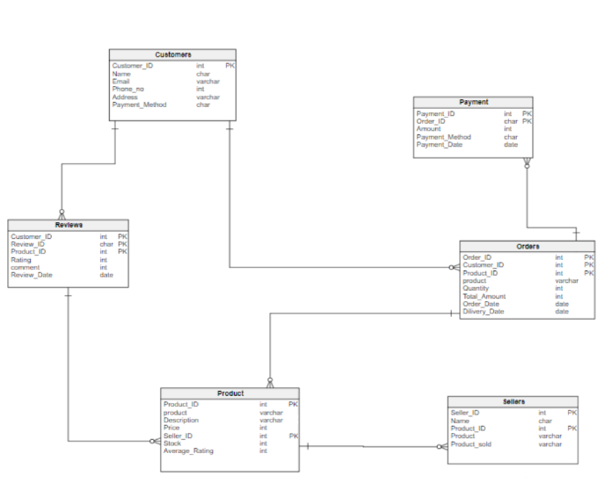

## **Presentation of Findings:**

**Impact of Schema Design on User Experience and Functionality:**

**Integration of Features:**

Important aspects such product listings, customer interactions, orders, reviews, and seller management are successfully included into a structured data model by the schema.

The user experience is improved by relationships between entities, which provide smooth linkages between orders, reviews, customers, and items.

**Improved Platform Functionality:**

Orders, products, and customer interactions may be efficiently tracked and managed thanks to the schema design, which enhances the usefulness of the platform.

Relationships between entities improve platform responsiveness by enabling fast access to client data, product details, and order history.

**Data Integrity and Reliability:**

The schema assures data integrity and dependability, lowering mistakes and inconsistencies in the database by enforcing foreign key constraints and creating appropriate relationships.

**Enhanced User Experience:**

Relationships between consumers, items, and reviews provide personalized recommendations, which enhance the user experience.

User comfort and happiness are increased by order tracking that is seamless and payment processing that is efficient.

**Support for Platform Objectives:**

**Scalability and Flexibility:**

Scalability to handle an increasing volume of orders, customers, and products is made possible by the schema's design, which supports Flipkart's goal of diversifying its offers.

**Optimized Product Management:**

Effective product management can be helped by the schema structure, especially the relationship between items and sellers, which allows sellers to list several items and helps customers browse different options.

**User-Centric Approach:**

Flipkart's belief in a user-focused strategy fits perfectly with the schema's design, especially in recording reviews and customer data, which facilitates better understanding and evolving to customer preferences.

**Efficient Order Processing:**

The schema makes order processing more effective by establishing linkages between Orders, OrderItems, and Payments. This helps Flipkart fulfill its promise to customers about fast deliveries and satisfaction.

**Summary**:

In conclusion, the Flipkart database schema design is essential to achieving the goals of the platform because it offers an organized structure that promotes efficient data management, reduced procedures, customized user experiences, and scalability to support the platform's expansion.